Project Design Phase-II
Data Flow Diagram & User Stories

Project Name | AI-based Threat Intelligence Platform

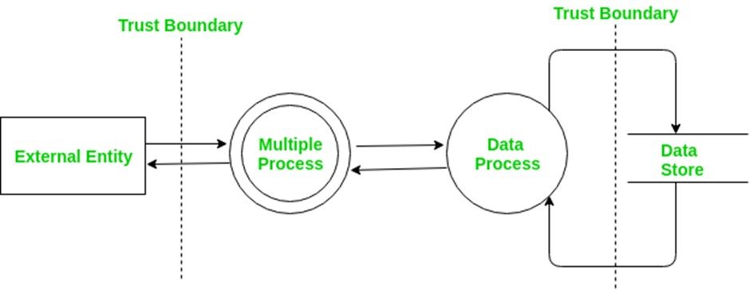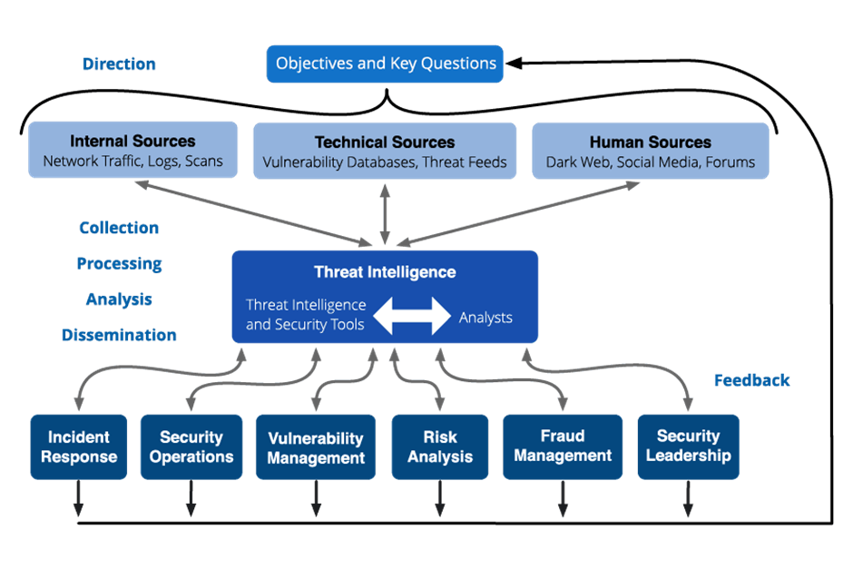

User Stories
User Type | Functional Requireme  nt (Epic) | User Story Number | User Story / Task | Acceptance Criteria | Priority | Release
Customer  (Mobile User) | AI-based  Threat Intelligenc  e | USN-  1 | As a user, I can register for the AI-based Threat Intelligence Platform by entering my email, password, and confirming my password. | I can access my AI-based threat intelligence dashboard | High | Sprint-1
Administrator | AI Model Configurat  ion | USN-  16 | As an administrator, I can configure the AI models used for threat intelligence, specifying the sources and data parameters. | AI models are configured and operational | High | Sprint-2
Customer (Web User) | Real-time  Threat  Alerts | USN-  17 | As a web user, I can receive realtime threat alerts on my dashboard based on AI analysis of incoming data. | I can see realtime threat alerts relevant to my account. | High | Sprint-3
Customer Care Executive | Incident Handling | USN-  18 | As a customer care executive, I can view and respond to AI-generated incident reports and take appropriate action. | I can access incident reports and follow the prescribed action plan. | High | Sprint-3
Administrator | Data  Integration | USN-  19 | As an administrator, I can integrate new data sources into the AI-based threat intelligence platform to enhance analysis. | New data sources are successfully integrated and contribute to threat analysis. | Medium | Sprint-4
Customer  (Mobile User) | Profile  Customiza  tion | USN-  20 | As a user, I can customize my threat alert preferences and notification channels within the AI-based platform. | I receive threat alerts through my preferred channels and for the selected types of threats. | Medium | Sprint-2

